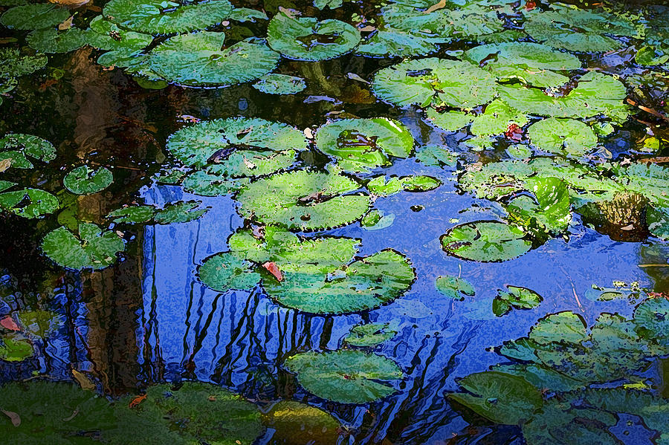
Day-of-Silence Autumn Retreat
Saturday, October 14th 9am-6pm
Welcome one and all! What a beautiful experience you are about to embark on.
This day is for YOU...your deepening growth and self-awareness, to create space to connect to nature and ground yourself, for receiving answers by being the observer, and all you intend for it to be! I look forward to sharing the space with you and invite you to come with an open heart and a deep love for yourself and your journey. Namaste.
In Silence:
While in silence, please keep interactions and non-verbal communications to a minimum.
If there are questions/concerns, tablets and writing utensils will be available for written communications. Also, please feel free to email Cassie with concerns prior to the event.

Registration: Thank you for your interest and commitment to growth!
Please complete the attached Registration Form and submit with payment by October 10th.

Items to bring: ***Please bring a journal, yoga mat, blanket, sweater/jacket, reusable water bottle.***
Additional suggested items; bolster, outdoor chair, book, bug-away spray, change of clothes should you choose to take a canoe out on the water, and anything else you think would be needed for “you time”!

Food/Drinks:
Water, tea, and juices will be provided throughout the day.
Fresh fruit smoothies, as well as granola and fixins, will be offered for breakfast.
Lunch will be provided as well. Catered by iCreate Café in Pottstown, of which many of you are familiar. Ash, the owner and sole operator, takes great pride in creating amazingly healthy, colorful vegan dishes and will share an assortment of goodies with us, including hummus, baba ganoush, pita, manaeish, tabboleh and bean salads, falafel, and much more!
Dinner will be POTLUCK style! Cassie will prepare a few vegetarian dishes to get the party started, please feel free to bring your own dish to share. If you are bringing a meat dish, please bring your own serving utensil. Labels will be available for ingredients listing! Thank you in advance for your edible contribution!
You are welcome to bring additional snacks if you are used to eating more frequently.

Retreat Space: We're Back! Happy to say, this will be our 6th Silence Retreat at CAMP INNABAH!
Camp Innabah is the name and the address is 712 Pughtown Rd, Spring City, PA 19475. The space offers indoor and outdoor options for you to spend your day! It is a beautiful space large enough for exploration but cozy enough to feel close to nature; bordering French Creek, walking trails, pavilions, cabins, swinging benches, open grass glen to picnic, campfire spaces, and so much more, it’s really a gem!
I rent a cabin just for our group so that can serve as your "home base". Bunk beds, fireplace, multiple bathrooms and a kitchenette are available to us throughout the day. Welcome welcome welcome!

Offered Events: All activities are optional, feel free to attend if you are drawn, or choose to spend time independently. Schedule, including meal times, is attached but please allow for small changes.

Optional full 24-hours of silence. Feel free to begin your silence before arriving; if you are looking for a true “day of silence” you can begin at 6pm the night before! When you arrive, there will be “In Silence” badges available until we all officially begin our silence.

Contact Information: Cassie Eshelman 484.300.3457 ceeshelman@gmail.com
Also on Facebook. www.cassieeshelman.weebly.com
Schedule of Events:
Saturday, October 14th 9am-6pm

All events are optional. They are provided to assist in the release of physical & emotional blockages and open the energetic pathways of the body, through movement, vibration, writing, etc. There are no obligations to participate in any of them. Please make the choice that best suits your needs, for your optimal retreat experience and enjoy!

9-9:30am Sign in.
Breakfast also available for you at your convenience.
9:30am Welcome and introductions
[and time for questions]!
10:00am SILENCE BEGINS

10:15-11:45am Outdoor Hatha Yoga Class
Class will begin with cleansing and recentering pranayama (breathwork) and will follow with a variety of poses and movements to open and cleanse the entire body. All are welcome, no prior experience with yoga necessary.
1:00-2:00pm Lunch is available for you at your convenience.

2:00-5:00pm All Around Free Time
Collection of spiritual/self-exploration books will be available.
Walking trails/outdoor space to hike, sit, rest, stretch, etc.
Indoor space available to read, journal, sit, rest, stretch, etc.
2:30-3:30pm
Native American Sound Ritual with Dave Antonio
Please welcome Dave to the camp, his first silence retreat experience with us.
Full moon ritual, sound healing, instrumental meditation. Didgeridoo, flutes, drums, etc.
4-5:00pm JourneyDance with Kelly Thomke
Kelly Thomke is a certified JourneyDance facilitator, trained by its creator, Toni Bergins. The dance form is a departure from kinetic or yogic dance and seeks to cleanse and heal the mind, body, soul and spirit through freestyle movement. Set to inspiring world music, we move barefoot with eyes closed as we let go & become transformed.
5-6:00pm Potluck Dinner
Several vegetarian main dishes will be provided. Please feel free to bring a dish, side, beverage, or snack to share during this time!
6:00pm Break Silence and Closing Thoughts
If you desire to stay in silence, silence badges will be available.
Karma Yoga Project will be available throughout the day, thank you in advance for giving back to the land and sacred space.
Day-of-Silence Autumn Retreat
Registration Form

Name ____________________________ Phone Number (_____) _____- __________

Address ______________________________________________________________________

Email Address ______________________________________________________________

Emergency Contact:
Name __________________________________ Relationship __________________
Phone Number (_____) _____- _________
Health & Diet Information:
Do you have any chronic illness or physical problems we should be aware of?
If so, please elaborate. ________________________________________________________
Please list any allergies you may have. ___________________________________________
Please note any accommodations that can be made to make your experience more comfortable. _____________________________________________________________________
Please note your dietary restrictions. ____________________________________________
Do you have experience with Yoga? If so, please elaborate.
__________________________________________________________________________________
Do you have experience with Silence Retreats? If so, please elaborate. __________________________________________________________________________________
How did you find out about the retreat? __________________________________________

Cost is $60 per person; includes all events and meals.
Gift certificates available as well, please request in advance.
Payment can be given in person in cash or check form. PayPal accepted as well.
Check can also be sent to Cassie Eshelman, 2152 Farmington Ave, APT3, Boyertown PA 19512. Please label check: “Silence Retreat”.
Registration deadline is October 10th. Thank you!

EVENT DISCLAIMER:
Please review. By adding your signature, you accept this waiver and disclaimer.
By participating in this event, I do so at my own risk. I assume all risk of injury, illness, damage or loss to me or my property that might result, including without limitation, any loss or theft of personal property. I assume all risk of injury on the grounds of the property where event is held. I consent to emergency contact being notified if medical treatment or assistance be needed in the event of injury, accident and/or illness during the event.
I acknowledge that I have carefully read this waiver and fully understand that it is a release of liability.
“I AGREE” Sign here: ____________________________________ Date: _____________

